Renju lesson on January 11, 2001

Hello all! Welcome to Online Renju Class. We will continue learning d8 opening today. I do not know how many of you use this opening in renju tournament, but I think it would have been a wise choice to use it in many games.
Namic suggests that we study 12-j9. That’s good. Actually, this is maybe the strongest 12th move, and black win is really difficult. The win comes through the series of difficlt positional moves. Actually, I have no written record of all possible variants here. I know the beginning development ideas here, and in the real game I would just use my experience and thinking to find the win in the end. Perhaps there would be hundreds of variants if you want to write down all different paths. We do not have that much time, therefore I suggest that we only focus on development ideas rather than displaying some particular sequences.
Speaking of the 13th move, it is quite obvious – black uses positional style. Those who are familiar with this expression they know that positional style means development and controlling at the same time. So, that should give you hint, where is the right 13th move. Do you all know? Yes, k9 is the only good move here. Do you know why? Who can explain? Yes, all of you had good answers. I am pleased.
I try to explain it too: How to choose the 13th move? Black has some material, two open pairs, can they help to have VCT? Not enough. Well, then we need to develop more. Can we just play somewhere and create as many lines as possible? Maybe, but we have to check whether white can counter-attack or not. Lets look. White has 3x3 threat at k9. So, black cannot just develop softly somewhere. Black has to defend. But defense without attacking ideas is poor – therefore black has to defend and also create some stuff for its own attack. The point k9 is the best solution – it blocks everything that white had, and also creates some additional material for black’s attack.
Remember, you can use exactly the same thinking method for every move in your game.
14-g5 – this is the strongest defense. Note that white is not playing it in the purpose of attack, but in the purpose of defense. After that white can control black’s pair from point h5. White does not have enough source to attack and win, therefore it has to defend anyway. And the best defense plan is to play g5 and control one of the black lines, and then block somewhere in upper area.
What is black’s next move? Most of you say j8. Lets try it out and see if it is good or not. Move 15-j8 can get the tempo and let black continue attack. Most players are tempted to get a chance to continue attack. But you must remember the rule – do not try to get the tempo or initiative when you have nothing to do with it.
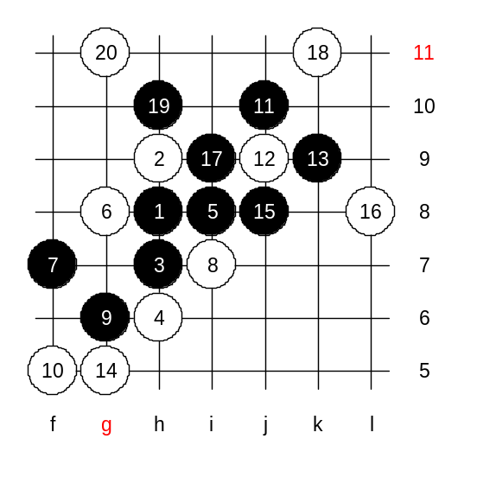
Yes, namic, 15-j8 forces white to defend. But I an teaching you to have an ability to see a little farther than that. Lets analyse: 15-j8 forces white to defend. OK. White blocks at L8. Then, black can continue attack. Can he win? Lets find out. If not, then white position is already too powerful below and because of absence of black VCT above, black will be in danger. So, remember the rule: you should only try to play move like 15-j8 only when you are SURE what after that you have VCT win. If there is no win, then you just get yourself into trouble because black will waste all his promising attacking points, and later has to defend white structures below, and black will most likely lose the game sooner or later. Do you understand?
So, our task is to find out, does black have that VCT or not. If not, then the j8 was a bad move.
How to attack? I explain the attacking idea: Black wants to use points h10, g10, e8, g7, d7. But does black have a proper sequence for that? Can anyone prove winning sequence here? As you see, black has no win because of absence of winning sequence. We have proved that move 15-j8 was bad, because you can look at the outcome – black attack has failed, and white has lots of promising material.

So, you may agree that 15-f4 is better.
Affine suggests 16-h5. Do you all think the same way? It is a good thinking that you want to use white’s initiative and block with h5 and still keep the tempo. But I must tell you, this is not the best thinking in this case. Do you remember I told you before, In most cases never use any three or four unless you are afraid that your opponent would take that point himself. Are you afraid that black would go to h5 himself? If black goes h5 then white defends happily at e8, and white will stand well. So, we are certain that black will not play to h5. Does black have VCT if white simply blocks in upper side? No. Well, in that case there is no hurry to play white stone to h5. And suppose that black will develop the attack so far that there will be already a VCT threat, then white will use that moment to play h5 first and block the black’s pair. Right timing matters a lot in renju. If you use your material either too early or too late then you are playing weak moves. Affine, why do you want to play h5 early and give black another black stone below, and the still continue defending above, when you could have just played above without giving black that extra stone.
The best way is to defend at L8.
This is the most difficult moment. It is hard to find the best 17th move if you do not have much experience about positional developing. The logic of positional development: Black has no VCT, white has no active material either, therefore black can continue with “soft” development moves.
Shineyes suggests i9? Well, this looks like a direct attack, and you all know that in case of absence of sure win, any direct attack just weakens the position. There is actually only one good move where the black win has been proved. Where is it?
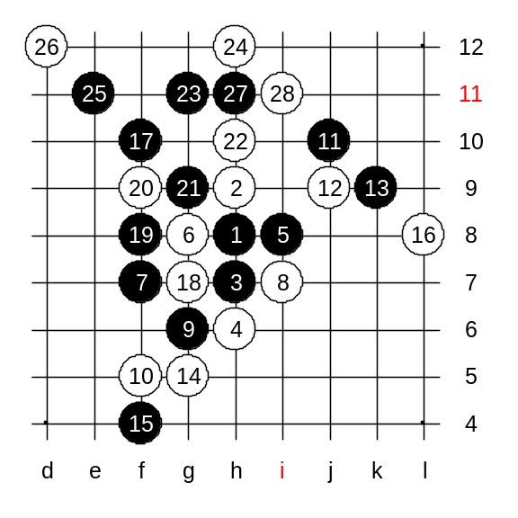
Yes, ki8 is right. 17-f10 is the winning move, it creates an open line as well as develops towards the space. Dino1, namic, concord2497 suggested f10, too. Since we do not have much time, we will only study one example of the 18th move.
Move 18-g7 is interesting – it is an active defense move. What should black do now? Should black go h5? You can find the best way if you follow the standard procedures of thinking: Does black have VCT? No. Does white have something active? Yes. So, black has to block. How to block? Black should block in the way that is most useful for black self. Is h5 useful for black’s own development? Not at all. So, h5 is out of question. Black moves f8 and g9 are much better. White plays h10 now. Any other white move is much weaker.
We have 28 stones on the board now. Black is very close to win.
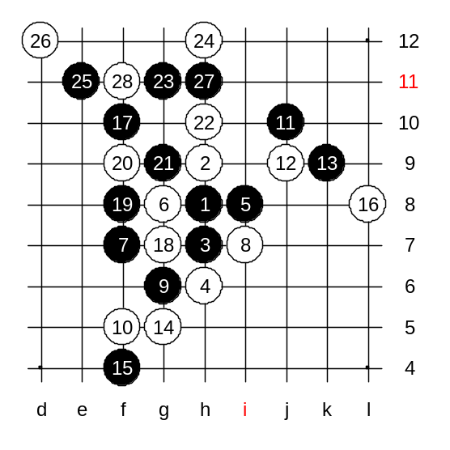
This is the medium level homework. Please find the black win.

This is the advanced level homework. Please find the black win.

The lesson is over now. Thank you all for coming. See you again next week!

